Introduction
CPU scheduling is the part of an operating system that decides which process should run on the CPU at any given moment. It exists because modern systems run many processes “at once,” while each CPU core can only execute one instruction stream at a time, so the OS must rapidly switch between ready processes to keep the processor busy and make the system feel responsive. Good scheduling improves overall throughput, reduces the time individual programs spend waiting, and helps interactive applications, such as editors or browsers, respond quickly to user input.
Real, production operating systems implement sophisticated schedulers to handle a wide variety of workloads and hardware. Systems such as MINIX use priority-based, preemptive scheduling with multiple queues to distinguish between kernel activities, I/O-bound tasks, and ordinary user processes, often combining priority levels with round-robin time slices inside each queue. Linux uses an even more advanced design: its main general-purpose scheduler, the Completely Fair Scheduler (CFS), tracks how much CPU time each runnable task has received and tries to approximate fair sharing of the processor, while also supporting real-time policies like FIFO and round-robin for time-critical threads. These production schedulers are powerful but complex, making it difficult for a student to modify or fully understand them directly within the kernel code.​
This project addresses that difficulty by studying classic CPU scheduling algorithms through a user-space simulator. Instead of changing the actual schedulers inside MINIX or Linux, the project re-implements foundational algorithms such as First-Come, First-Served (FCFS), Shortest Job First (SJF), Round Robin, and Priority scheduling, and then compares their behavior on controlled workloads. In MINIX3 using VMware makes it possible to experiment with different policies, visualize how processes move through the ready queue, and compute metrics like waiting time and turnaround time without the risks and overhead of rebuilding a full operating system kernel. This approach captures the core ideas used in real systems while remaining manageable within the time and tooling constraints of an undergraduate operating-systems course.
What CPU scheduling is
In a multiprogrammed system, multiple processes reside in memory at once, and whenever the currently running process blocks or its time slice expires, the OS must select another process from the ready queue to run on the CPU. The policy and algorithms used to make this choice are called CPU scheduling, and they determine how long processes wait, how quickly interactive programs respond, and how efficiently the CPU is utilized. Typical schedulers operate over a ready queue and apply rules such as “run the process that arrived first” or “run the process with the shortest predicted CPU burst next.”​
CPU scheduling can be non-preemptive, where a running process keeps the CPU until it blocks or terminates, or preemptive, where the OS can interrupt a running process to give the CPU to another ready process. Preemptive scheduling is essential for time-sharing systems, because it prevents any single process from monopolizing the CPU and enables quick, interactive response times for users. Classic algorithms studied in courses include First-Come, First-Serve (FCFS), Shortest Job First (SJF), and Round Robin (RR), each trading off simplicity, average waiting time, and fairness.​
Why CPU scheduling matters
Good CPU scheduling improves overall system throughput by keeping the CPU busy with useful work whenever there are ready processes available. It also reduces average waiting time in the ready queue, which is especially important when many users or services share the same machine. For interactive workloads, scheduling directly influences perceived responsiveness, since users experience delay whenever their processes sit in the ready queue.​
Scheduling policies can also enforce priorities among processes, for example ensuring that real-time or system tasks run before best-effort user jobs. However, naive priority rules can cause starvation if low-priority processes never receive CPU time, so real systems introduce mechanisms like aging to gradually increase the priority of long-waiting processes. Understanding these trade-offs is key to designing systems that are both efficient and fair across a wide range of workloads.​
Real OS schedulers
Real operating systems such as MINIX and Linux use schedulers that are far more sophisticated than the simple textbook algorithms, because they must handle multiple processor cores, real-time constraints, and a mix of CPU-bound and I/O-bound processes. For example, microkernel-based systems like MINIX 3 have a dedicated scheduler within the kernel that cooperates with other servers, and they often rely on priority-based and time-slice mechanisms to manage many concurrent activities. Linux uses a highly optimized, priority-aware scheduler designed to scale to many CPUs and thousands of processes while still providing low latency for interactive tasks.​
These production schedulers combine ideas from FCFS, SJF, and Round Robin with additional heuristics, priority queues, and load-balancing strategies. They must run efficiently themselves, because any time spent in the scheduler is overhead that does not directly contribute to application progress. As a result, the internal behavior of real schedulers is complex and can be difficult to experiment with safely inside a live operating system.​
Why build a scheduler simulator
Real OS schedulers are complex and tightly integrated with kernel code, they are hard to modify and dangerous to test with experimental policies; a bug can crash the entire system or corrupt state. This project experiments directly with the MINIX3 CPU scheduler by changing its priority and time-slice parameters and observing the impact on running processes. This provides a controlled environment where different algorithms and parameters can be explored rapidly.​
A simulator also makes it easier to visualize and measure metrics such as waiting time, turnaround time, and CPU utilization for different workloads and algorithms. Students can run repeatable experiments on FCFS, SJF, Round Robin, priority scheduling, and more advanced policies, comparing how design choices affect performance and fairness without needing kernel-level debugging skills. For a college-level operating systems course, building and using such a simulator offers a practical way to deepen understanding of CPU scheduling theory.
MINIX3 Tinkering and Testing
Project status: MINIX 3.3.0 VM running in VMware. Clang installed via pkgin. cpu_hog.c compiles and runs. Baseline scheduler responsiveness documented.
MINIX 3.4 Installation and Configuration on Oracle VirtualBox [2017]: https://www.youtube.com/watch?v=lKeXmdhiiRg

MINIX3 Downloaded and ready to use:
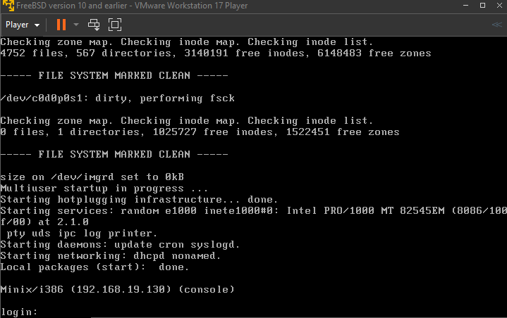
Login: root (default)
Feeling Out MINIX3: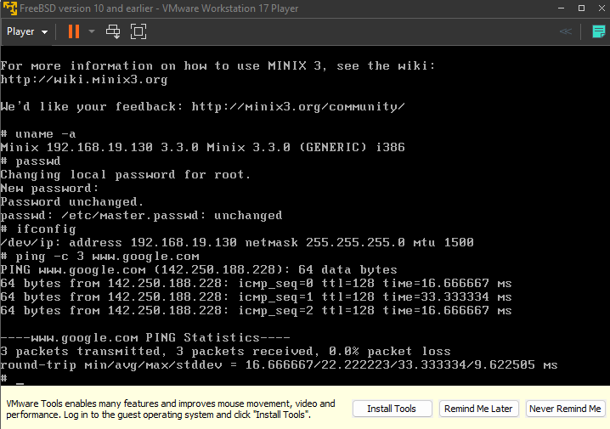
Looking through the directory in MINIX3.
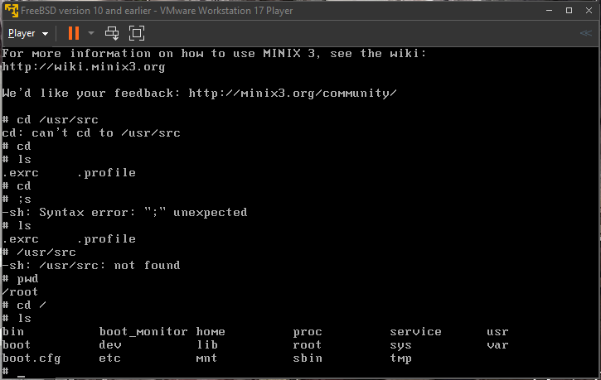

Installing the C Lang.
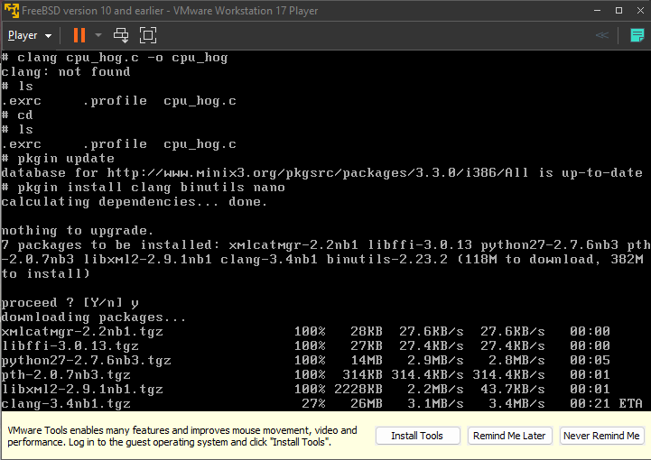

Created a CPU_hog.c file to do experiment:
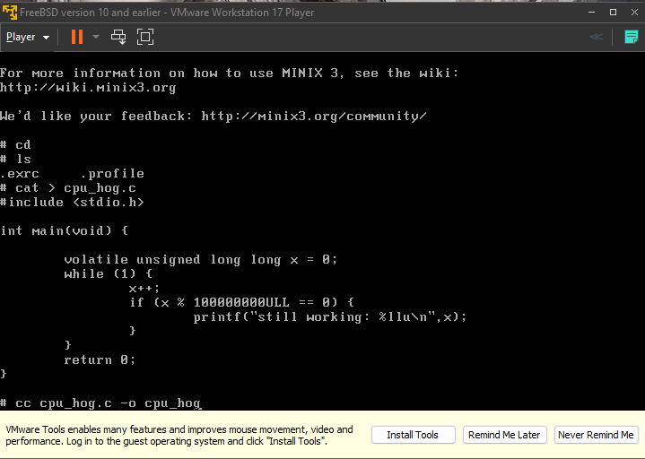
CPU_hog.c working:
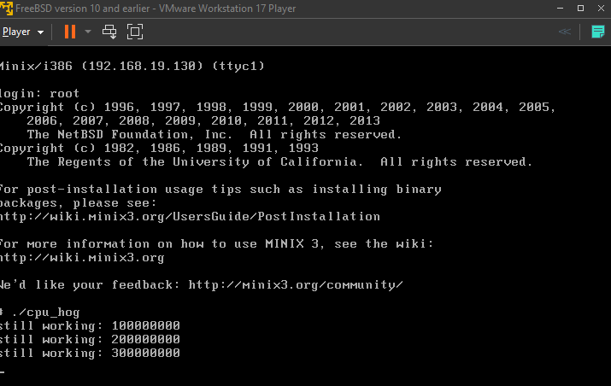
Test of CPU_hog.c:
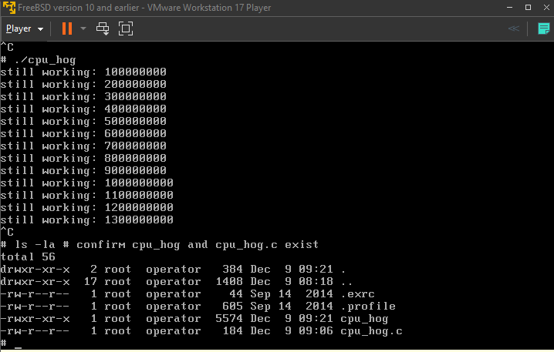
Results:
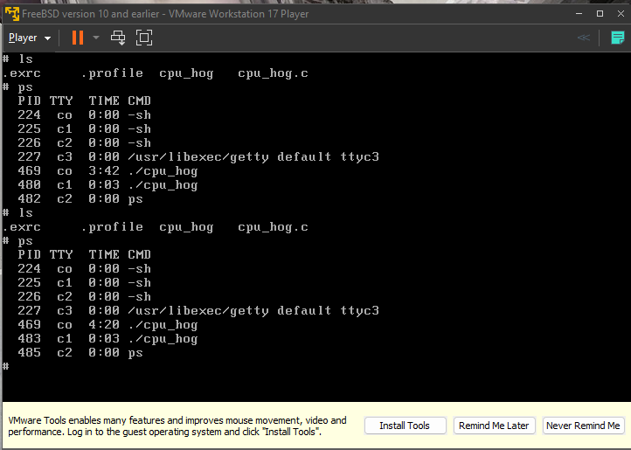
MINIX 3 cpuhog.c (Infinite CPU Hog Version)
c
/* cpuhog.c – infinite CPU hog for MINIX 3 scheduler testing
*
* Compile: cc cpuhog.c -o cpuhog
* Run: ./cpuhog
* In second terminal: top (watch CPU% spike then get preempted)
*/

#include <stdio.h>

int main()
{
volatile unsigned long long x = 0;

while (1) {
x++;
if (x % 100000000ULL == 0) {
printf("still working: %llu\n", x);
}
}

return 0; /* Never reached */
}
Key features that make this perfect for your project:
- while(1) infinite loop → Never voluntarily yields, pure CPU hog
- x++ tight loop → Maximum CPU usage (100% in top)
- if (x % 100000000ULL == 0) → Prints every ~100M iterations so you see it's still running
- volatile → Compiler can't optimize away the loop

Sources
- MINIX Scheduling Basics: https://www.minix3.org/docs/scheduling/report.pdf – Covers user-mode SCHED server, priority queues (TASK_Q, SERVER_Q), round-robin quanta, and CPU hog demotion. Directly ties to your cpu_hog.c tests.​
- Bash Loadable Builtins: https://www.gnu.org/software/bash/manual/html_node/Bash-Builtins.html (official docs) – Explains .def/.c → .so compilation and enable -f loading, matching your Day 1 docx exactly.​
- Linux CPU Scheduling Intro: https://pmc.ncbi.nlm.nih.gov/articles/PMC11066403/ – General CFS vs. RR comparison with metrics (wait time, utilization); use for analysis without deep kernel dive.​
- Your Setups: VMware Workstation notes + Ubuntu VM from docx; cite GitHub repo once pushed.

